PARAG SONI – R00208553
SCIENTIFIC PROGRAMMING IN PYTHON
FINAL PROJECT

INTRODUCTION

In this report, I am going to demonstrate a web application created for users to allow them to explore some of the most interesting aspects of the dataset.

The dataset is the IMDB movie dataset hosted by kaggle which contains the details of over 5043 movies scraped from the IMDB movie website. The dataset have 28 features describing each movie.

PROJECT SPECIFICATION

The objective of this project is to produce an application and report that allows the user to explore some of the most interesting aspects of the
IMDB dataset.

In this project or application user has been put up with 6 options, and makes a choice from the listed options, to explore the dataset. User see the below output on his screen.

Please select one of the following options:
1. Most successful directors or actors
2. Film comparison
3. Analyse the distribution of gross earnings
4. Genre Analysis
5. Earnings and IMDB scores
6. Exit
The user must enter 1,2,3,4,5 or 6 for selection. If the user selects any option from 1-5 then program display the associated output and will display the main menu again. If the user selects option 6, application exits. If user selects any option other than the listed one’s, in that case the user has been notified with a error that “Invalid input! Please try again.”.
Depending on the selected option user can see the graphical representation of the choice he made for example if he selects 1st option it would be a horizontal bar graph of most popular actors or director and similarly for others.

OPTION DESCRIPTION
- Most successful directors or actors
It displays a graphical representation (a horizontal bar graph) of most successful actors or directors.
Whenever user selects this option he/she is prompted with a menu:
i. Top Directors
ii. Top Actors
The user must enter 1 for listing top directors and 2 for listing top actors.
After selecting one of the two option user Is again prompted with choice to enter how many actors or director he/she wants to see.
The first step is dropping or replacing missing values with usage of Pandas's "dropna" or "fillna" method. Thus, with the "dropna" command, the missing data in the “director_name” and “actor_name_1” columns are deleted. With "fillna" command, the missing data in the “gross” column is filled with "0".
After dealing with null values, a new data frame(director_gross_df_and_sorted_director_gross_df) is created with director_name and gross columns for option 1. “Top Directors”, similarly for for option 2 “Top Actors” new data frames actor_gross_df and sorted_actor_gross_df with actor_name_1 and gross columns. After that data frame is sorted according to "gross" values and the indexes are reset.
Later, the number of actor or director choice entered by user is read and that number of data is stored from the sorted data frames above.
Finally, using top_directors/top_actors and gross lists, the horizontal bar graph is displayed with in descending order of gross.

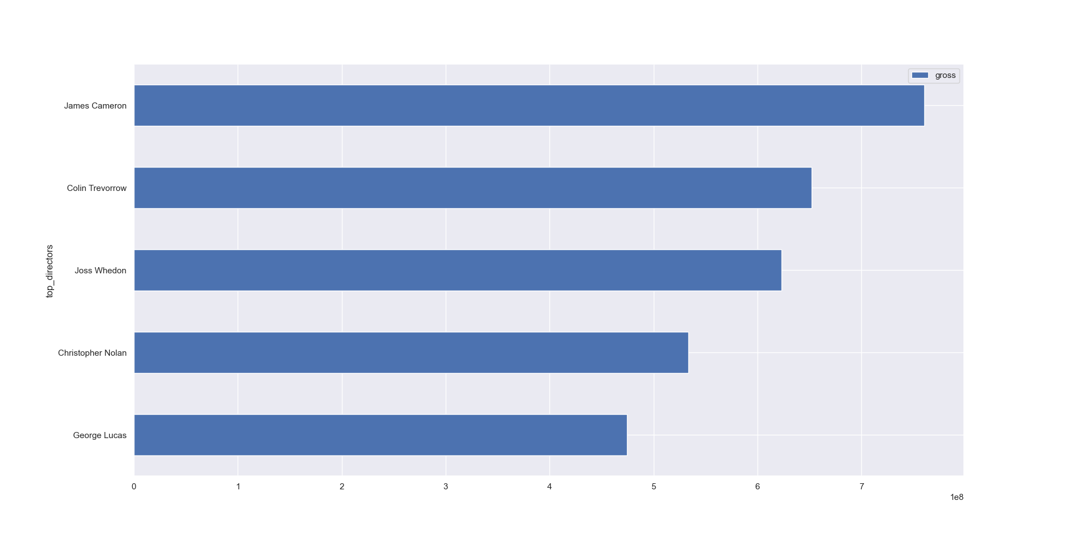
Figure 1 – Top Directors

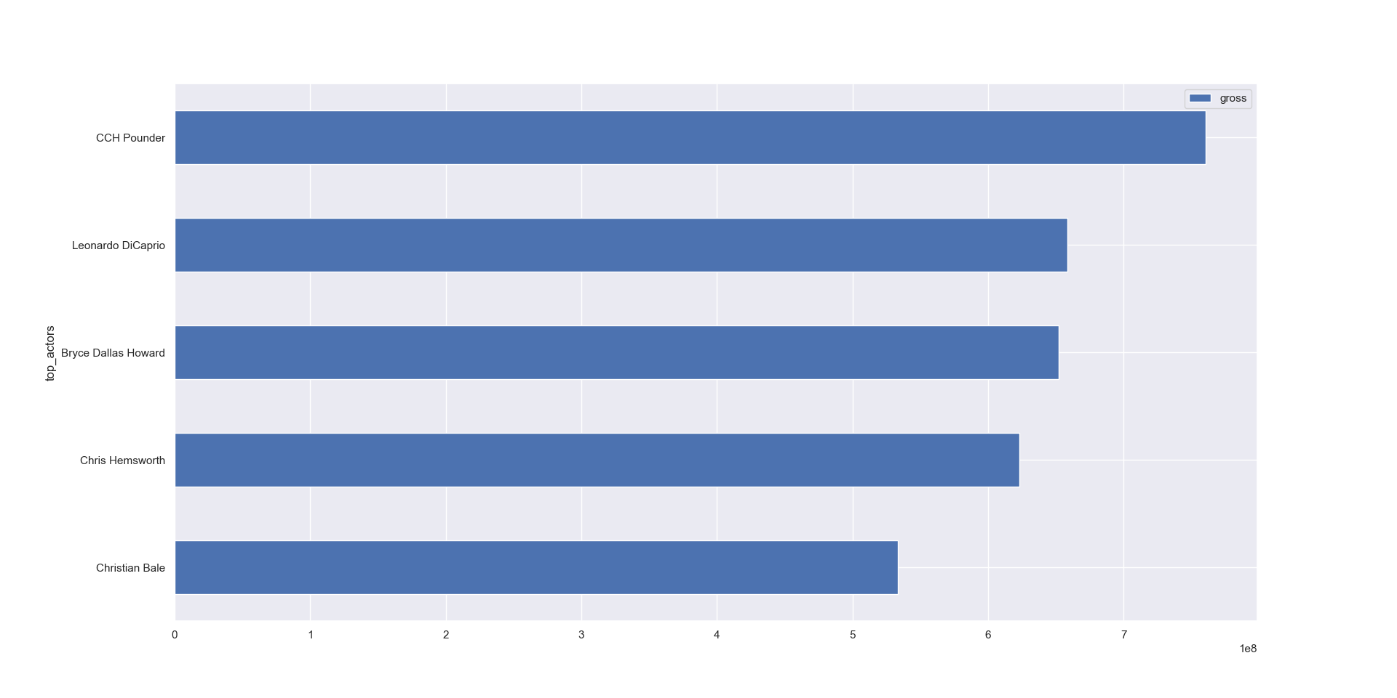
Figure 2 - Top Actors
- Comparison of Two Films
In this given choice, user can compare any two movies of his/her choice by either of the three options given
- IMDB Scores
- Gross Earning
- Movie Facebook Likes
Output will show a bar graph comparing both the movies based on whatever comparator user wants to go with
Thus, movie_title, imdb_scores, gross and movie_facebook_likes columns of dataset are used.
Similar kind of process is followed to sort the dataset by comparator.
The missing values in movie_title, imdb_scores and movie_facebook_likes columns. Thus, with "dropna" command, the missing data in the gross column are handled.
After cleaning data, it is checked whether the movie names entered by the user are in the dataset and whether the two movie names are different.
At last rows matching the movies names of columns IMDB scores/Gross earnings/Movie Facebook likes are taken out and assigned to a variable.
Finally, these variables are represented by a bar plot like below:
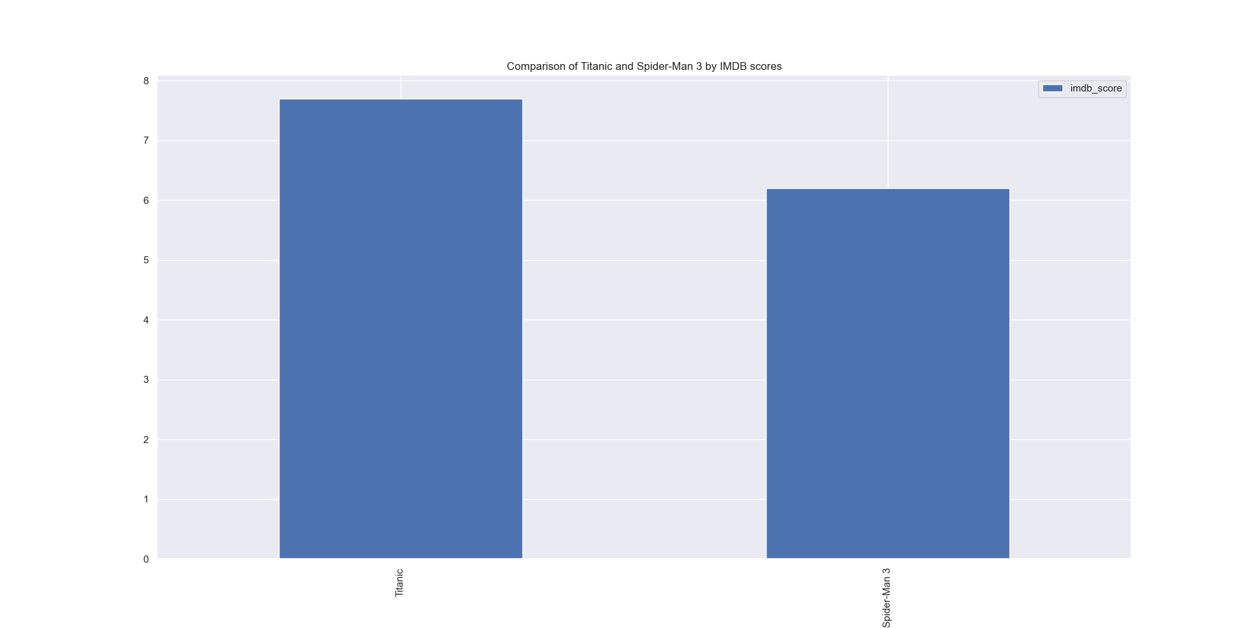
Figure 3 – Comparison by IMDB
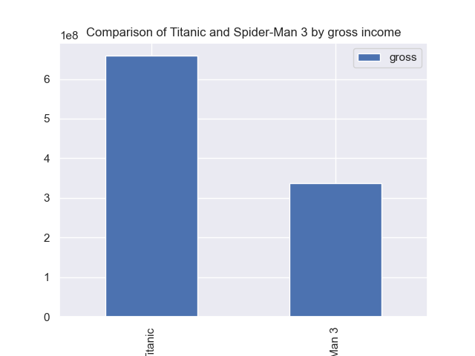
Figure 4 – Comparison by gross income
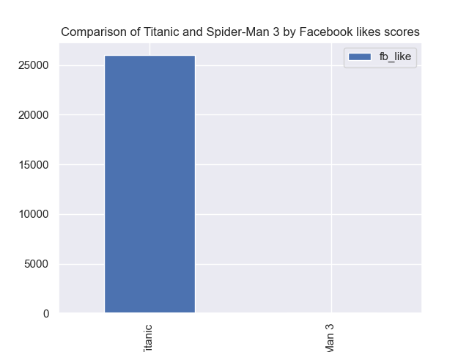
Figure 5 – Comparison by Facebook likes

- Graphical representation of some descriptive statistics of gross earnings for each year between specific years (minimum, maximum, and average)
In this option, user can see the average, minimum and maximum gross earning of movies between his choice of time period.
In this title_year and gross coumns of data set are used.
Initially handled null values in gross column and stored the minimum and maximum year entry present in our dataset in a variable.
Later I verified whether the entered start year and end year by user lies the range of our maximum and minimum year and if not we throw a error “Invalid input! Please enter films that made between 1920 and 2016.”
At last a new data frame is created with minimum, maximum, average gross earnings and years between user entered start year and end year.
Minimum, maximum and average gross earnings are obtained by using Pandas's min(), max() and mean() methods.
Finally we present a line graph displaying the minimum, maximum and average gross earning for that time period on a line graph like below.
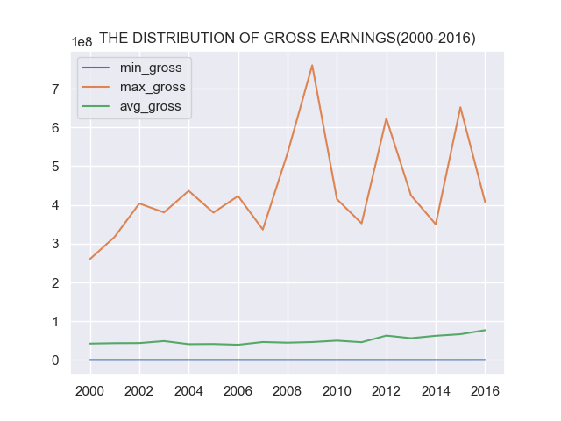
Figure 6 – Gross earning compare

- Calculation of the average IMDB score of all films of a specific genre entered by the user
In this option, average IMDB scores of the genre selected by user is printed as a text on console.
imdb_score, movie_title and genres columns are used for this operation.
The first step is handling missing values in same manner as previous.
Later a new dataframe with only genre column is created from main dataset and to store and display only unique values, it is later iterated and stored in a set.
Later we display a list of all unique genres of movies available in dataset, and asks user to choose any one the listed genre in order to show its mean IMDB score of all films within that genre and as soon as user selects genre, desired output is displayed..
Output:
List of Genres:
Short
Crime
Romance
Film-Noir
Action
War
Thriller
Musical
Mystery
Biography
History
Sport
Western
News
Fantasy
Animation
Family
Music
Sci-Fi
Comedy
Drama
Adventure
Horror
Documentary

Enter a genre to see mean IMDB score of all films of that genre:
Enter genre here: Sci-Fi

The mean IMDB score of all films within Sci-Fi genre is 6.3

- Relationship Between the IMDB Column and the Other Features

If user selects this option a heat map/ correlation map of all the columns is displayed on the graph describing the kind of relationship (evaluated by p-value) IMDB has with rest of the columns.
The p-values are also printed on screen for user’s convenience.
Output:
Correlation between IMDB scores and other numerical data:

num_critic_for_reviews | 0.335129
duration | 0.363938
director_facebook_likes | 0.185116
actor_3_facebook_likes | 0.060252
actor_1_facebook_likes | 0.086191
gross | 0.197785
num_voted_users | 0.462297
cast_total_facebook_likes | 0.098289
facenumber_in_poster | -0.065256
num_user_for_reviews | 0.320407
budget | 0.027532
title_year | -0.201367
actor_2_facebook_likes | 0.095453
imdb_score | 1
aspect_ratio | -0.007681
movie_facebook_likes | 0.26614

Heat map:

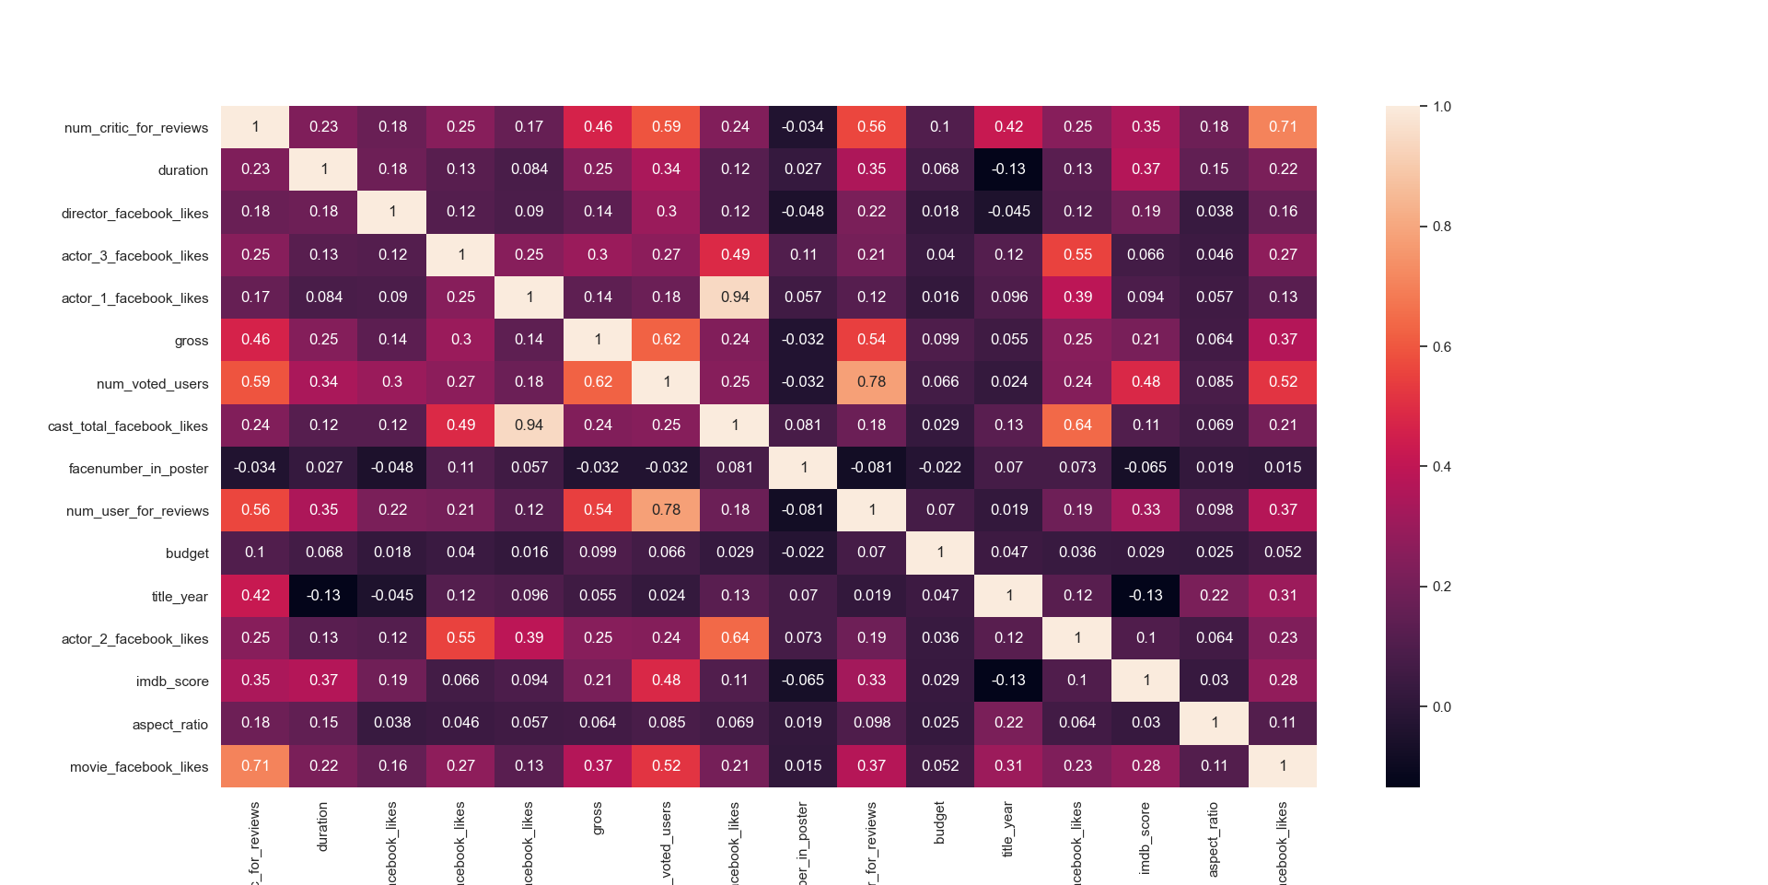

Figure 7 – Heat Map

- Exit

On selecting this option the program terminates.

